# A MINI PROJECT REPORT ON

**“Ultrasonic Glasses For the Blind”**

Submitted By

# 1] Mr. Sarthak Devidas Varade (Roll.no-68) 2] Mr. Onkar Uttam Waman (Roll.no-73) 3] Mr. Omkar Sunil Yelmame (Roll.no-74)

Under the Guidance of Prof. R. K. Kharat



# Department of Electronics and Telecommunication Engineering (Academic Year: 2022-23)

**Amrutvahini College of Engineering, Sangamner.**



**CERTIFICATE**

**This is to certify that the Mini Project report on**

**“Ultrasonic Glasses For the Blind”**

**Has been successfully completed by: -**

**1] Mr. Sarthak Devidas Varade (T190103076)**

**2] Mr. Onkar Uttam Waman (T190103082)**

**3] Mr. Omkar Sunil Yelmame (T190103083)**

In partial fulfilment of Mini Project of E&TC Engineering

In Savitribai Phule Pune University for Academic year 2022-23

**Prof. R. K. Kharat Prof. R. K. Kharat Dr. R. P. Labade**

**Mini Project Guide Mini Project Coordinator HOD, E&TC**

**Dr. M. A. Venkatesh**

**Principal, AVCOE, Sangamner**

**Savitribai Phule Pune University**



**CERTIFICATE**

This is to certify that,

# 1] Mr. Sarthak Devidas Varade (Roll.no-68) 2] Mr. Onkar Uttam Waman (Roll.no-73) 3] Mr. Omkar Sunil Yelmame (Roll.no-74)

Student of Department of Electronics and Telecommunication Engineering was examined in the seminar work entitled

**“Ultrasonic Glasses For the Blind”**

**INTERNAL EXAMINER EXTERNAL EXAMINER**

# Place- Sangamner Date- / /20

**ACKNOWLEDGEMENT**

We would like to take this opportunity to express our respect and deep gratitude to our guide Prof. R. K. Kharat, for giving us all necessary guidance required, for this project, apart for being constant source of inspiration and motivation. It was our privilege to have worked under her.

We are thankful to H.O.D. Dr. R. P. Labade & Principal Dr. M. A. Venkatesh for the regular guidance, co-operation, encouragement and kind help. We are also thankful to all the faculty members and staff of the department for their kind support and cooperation during the project work.

We are highly obligated to our entire friends, whose contribution intellectually and materially in the words and deeds for preparation of this Seminar report. We are also thankful to all our teaching and non-teaching staff for their enormous support.

# Sarthak Devidas Varade Onkar Uttam Waman

**Omkar Sunil Yelmame**

# CONTENTS

|  |  |  |
| --- | --- | --- |
| **Chapter No** | **Name of Topic** | **Page No.** |
| 1 | Introduction | 8 |
| 2 | Literature Review | 9-10 |
| 3 | Related Work | 11 |
| 4 | Aim & Objectives | 12 |
| 5 | Need of Project | 13 |
| 6 | System Development | 14 |
| 7 | Components | 15-22 |
| 8 | Architecture of Project | 23-24 |
| 9 | Working | 25-26 |
| 10 | Arduino Code | 27-28 |
| 11 | Advantages, Limitations and Applications | 29 |
| 12 | Conclusion | 30 |
| 13 | References | 31 |

**LIST OF FIGURES**

|  |  |  |
| --- | --- | --- |
| **Sr no** | **Name of Figure** | **Page No** |
| 1 | Block Diagram | 14 |
| 2 | Arduino UNO | 15 |
| 3 | Ultrasonic Sensor (HC-SR04) | 16 |
| 4 | PIR Motion Detector Sensor Module (HC-SR501) | 17 |
| 5 | Flat Vibration Motor Module (1034) | 18 |
| 6 | Active Buzzer Module | 19 |
| 7 | 9V Battery | 20 |
| 8 | Battery snap(9V) with DC jack | 21 |
| 9 | SPDT slide switch | 21 |
| 10 | Male to Female jumper wires | 22 |
| 11 | Simulation of Project | 23 |
| 12 | Prototype (model) | 24 |
| 13 | Flowchart | 25 |

**ABSTRACT**

The project titled "Ultrasonic Glasses For the Blind" aims to develop a groundbreaking assistive device that enhances the mobility and independence of visually impaired individuals. These innovative glasses utilize ultrasonic technology to detect and analyze objects in the surrounding environment and also can distinguish between humans and non-living obstacles. By emitting ultrasonic waves and measuring their reflections and measuring heat radiation of obstacle, the glasses generate real-time spatial information, which is then conveyed to the user through haptic and audio feedback.

The project ensures this by increasing mobility, safety, and autonomy, this assistive technology has the potential to significantly improve the quality of life for visually impaired individuals, enabling them to participate more fully in various activities and environments. The overall goal is to create a cost-effective, accessible, and user-friendly solution that enhances the independence and inclusion of individuals with visual impairments.

# CHAPTER 1 INTRODUCTION

Ultrasonic glasses for the blind is an innovative technology that aims to assist blind or visually impaired individuals in navigating their environment. These glasses use ultrasonic waves to detect objects and obstacles in the wearer's surroundings and convert this information into haptic feedback, providing a clearer picture of their environment. This technology has the potential to improve the quality of life for individuals who are blind or visually impaired, allowing them to navigate unfamiliar environments with more confidence and independence. Additionally, ultrasonic glasses can offer a more discreet and less invasive alternative to traditional assistive devices such as canes or guide dogs. Guide dogs and white canes are major tools to support the visually impaired. However, the number of guide dogs is predominantly smaller than, the number of visually impaired persons [2]. With the continuous advancements in technology, ultrasonic glasses for the blind may become more accessible and widely available in the near future.

While ultrasonic glasses for the blind are still a relatively new technology, they are rapidly evolving. Newer versions of the glasses are becoming smaller, lighter, and more affordable. Advances in artificial intelligence and machine learning are also being incorporated into the technology, allowing the glasses to learn from the wearer's movements and adapt to their needs.

**CHAPTER 2**

# LITERATURE REVIEW

1**] "Automated Walk-in Assistant for the Blinds" by Muhammad Sheikh Sadi, Saifuddin Mahmud, Md. Mostafa Kamal, Abu Ibne Bayazid (IEEE 2014)**

This paper presented an automated walk-in assistant system designed to aid visually impaired individuals in navigating their surroundings. The system utilized ultrasonic sensors to detect obstacles and provide real-time audio feedback to the user. The authors implemented a microcontroller-based approach to process sensor data and generate appropriate audio instructions. The study showcased promising results in terms of obstacle detection and user assistance, contributing to the field of assistive technology for the visually impaired.

# 2] "A Wearable Walking Support System to provide safe direction for the Blind" by Kataoka Hiroto, Harashima Katsumi (IEEE 2019):

This research introduces a wearable walking support system that aims to provide safe direction for blind individuals. The system incorporates various sensors, including cameras, distance sensors, and gyroscopes, to detect and analyze the surrounding environment. It utilizes auditory cues and tactile feedback to guide users and prevent collisions. The study presents the system's design, functionality, and performance evaluation.

# 3] "Development of Glasses for Guiding Visually Impaired Using Ultrasonic Sensor and Microcontroller" by Wawan Setiawan, Rasim, and Jajang Kusnendar (JMEST 2014)

The writer has put forward a technique which utilizes GPS and GSM to ascertain alcohol but this technique is very expensive, but the expenses can be cut off to a great extent. In this project a siren is being used which is highly economical, and can keep people in close proximity vigilant. Wearing smart helmet to prevent any mishap is suggested by writer which have certain deficiencies. Firstly restrictions on the use of helmets to only 2 wheelers. Secondly, microcontrollers are software based mega system in comparison to the economical siren that are open-source hardware.

Savitribai Phule Pune University, Pune2019 Course

# 4] "A Unique Smart Eye Glass for Visually Impaired People" by Md. Razu Miah, Md. Sanwar Hussain (IEEE 2018)

The paper presents a unique smart eyeglass system designed specifically for visually impaired individuals. The system combines ultrasonic sensors, GPS, and a microcontroller to assist users in object detection, obstacle avoidance, and navigation. The study discusses the system architecture, sensor integration, and software implementation. It also presents results from user testing, highlighting the potential benefits and limitations of the proposed smart eyeglass solution.

# CHAPTER 3 RELATED WORK

* 1. Recently, many electronic travel aids (ETAs) devices with advanced technology and computer vision system are introduced to assist the blind for safe and independent walking. Some of those devices are NavBelt, Guidecane,VA-PAMAID, Laser cane, Guide Dog Robot, Mowat sensor, KASPA.The NavBelt consists of a belt with a small computer, ultrasonic and other sensors. Signals from these sensors will be processed by a unique algorithm and relayed to the user via headphones[1]
  2. Guide dogs and white canes are major tools to support the visually impaired. However, the number of guide dogs is predominantly smaller than, the number of visually impaired persons. On the other hand, visually impaired persons can easily use white canes. However, they have to train sufficiently to master ones. In addition, they can only make a situation judgment only around the feet with white canes.[2]
  3. Blind people traditionally use a wand to detect the presence of objects that get in the way, for the information of the stick, it was decided to walk straight, turn left, or right. Reach an average of 1 m2 with partial information where the information obtained is not at the same sequence. Based on the principle of wall follower can be used as a tool for blind people in the form of glasses equipped with a proximity sensor capable of detecting the presence of obstacles in a wider range with richer information in a short time so that the response / action can be done.[3]
  4. Since the weak sighted people have some degree of visual perception, and vision can provide more information than other senses, e.g. touch and hearing, the visual enhancement, which uses the popular AR (Augmented Reality) technique for displaying the surroundings and the feasible direction on the eyeglasses, is proposed to help the users to avoid the obstacle[5]

Savitribai Phule Pune University, Pune2019 Course

# CHAPTER 4

**AIM:**

To design and develop a wearable device that utilizes ultrasonic sensor & PIR sensor to detect obstacles and provide haptic and sound feedback, allowing visually impaired or blind individuals to navigate their surroundings with greater independence and safety.

# OBJECTIVES:

1. To detect obstacles within a range of at least 2 meters in front of the wearer, including objects at ground level, waist height, and head height.
2. To provide haptic feedback to the wearer in real-time, alerting them to the presence and proximity of obstacles through vibrations.
3. To distinguish whether obstacle is radiating heat(humans) or not.
4. To be lightweight and comfortable to wear, affordable and accessible.

# CHAPTER 5

**NEED OF PROJECT**

There are more than 285 million people who are visually impaired all over the world. Among them 39 million people are blind and 246 million people have some visual impairments like low vision. The number of these kind of people is growing day by day. Blind and visually impaired individuals face significant challenges in navigating their surroundings. With the limitations and drawbacks of traditional assistive devices, such as canes and guide dogs, ultrasonic glasses use ultrasonic waves to detect objects and obstacles in the wearer's surroundings, providing a clearer picture of the environment. This can significantly improve the mobility and independence of blind and visually impaired individuals, allowing them to navigate unfamiliar environments with more confidence and ease.

# CHAPTER 6 SYSTEM DEVELOPMENT

1] Block Diagram-

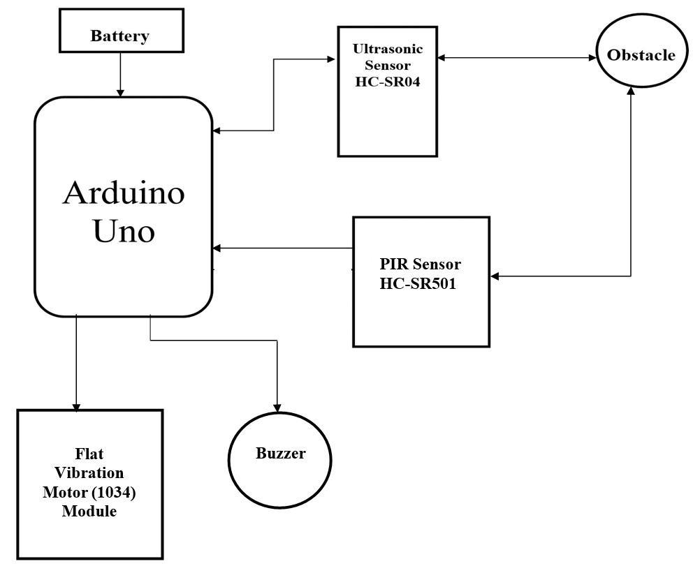

Fig 1-Block Diagram

# ARDUINO UNO

**CHAPTER 7 COMPONENTS**

The **Arduino Uno** is a microcontroller board based on the ATmega328. Arduino is an open-source, prototyping platform and its simplicity makes it ideal for  hobbyists to use as well as professionals. The Arduino Uno has 14 digital input/output pins (of which 6 can be used as PWM outputs), 6 analog inputs, a 16 MHz crystal oscillator, a USB connection, a power jack, an ICSP header, and a reset button. It contains everything needed to support the microcontroller, simply connect it to a computer with a USB cable or power it with an AC-to-DC adapter or battery to get started.

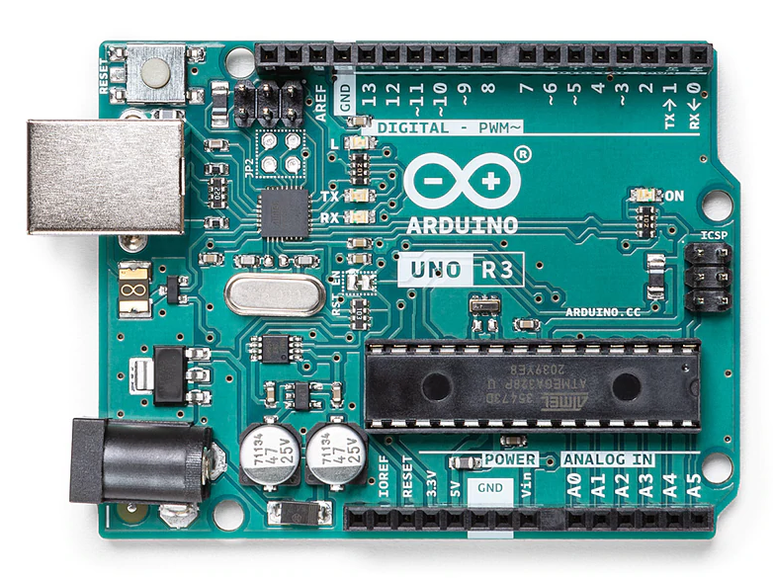

Fig 2- Arduino UNO

**Specifications:**

* Microcontroller: ATmega328P
* Operating Voltage: 5V
* Input Voltage (recommended): 7-12V
* Input Voltage (limits): 6-20V
* Digital I/O Pins: 14 (of which 6 provide PWM output)
* Analog Input Pins: 6
* DC Current per I/O Pin: 40 mA
* DC Current for 3.3V Pin: 50 mA
* Flash Memory: 32 KB of which 0.5 KB used by bootloader
* SRAM: 2 KB (ATmega328)
* EEPROM: 1 KB (ATmega328)
* Clock Speed: 16 MHz

1. **Ultrasonic Sensor (HC-SR04)**

The HC-SR04 Ultrasonic distance sensor consists of two [ultrasonic transducers](https://en.wikipedia.org/wiki/Ultrasonic_transducer). The one acts as a transmitter which converts electrical signal into 40 kHz ultrasonic sound pulses. The receiver listens for the transmitted pulses. If it receives them, it produces an output pulse whose width can be used to determine the distance the pulse travelled. The sensor is small, easy to use in any robotics project and offers excellent non-contact range detection between 2 cm to 400 cm (that’s about an inch to 13 feet) with an accuracy of 3mm. Since it operates on 5 volts, it can be hooked directly to an Arduino or any other 5V logic microcontrollers.

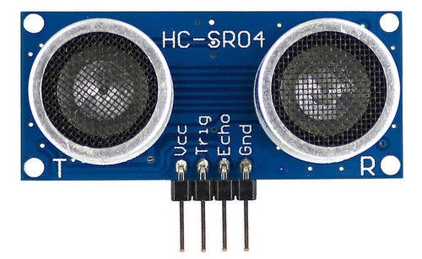

Fig 3- Ultrasonic Sensor (HC-SR04)

**Specifications:**

* Operating Voltage: DC 5V
* Operating Current: 15 mA
* Operating Frequency: 40 KHz
* Max Range: 4 m
* Min Range: 2 cm
* Ranging Accuracy: 3 mm
* Measuring Angle: 15 degrees
* Trigger Input Signal: 10 μS TTL pulse
* Dimension: 45 × 20 × 15 mm

# PIR Motion Detector Sensor Module (HC-SR501):

The PIR Motion Sensor Detector Module HC SR501 allows you to sense motion. It is almost always used to detect the motion of a human body within the sensor’s range. It is often referred to using “PIR”, “Pyroelectric”, “Passive Infrared” and “IR Motion” sensors. The module has an onboard pyroelectric sensor, conditioning circuitry, and a dome-shaped Fresnel lens. It has a delay time adjustment Potentiometer and sensitivity adjustment Potentiometer.

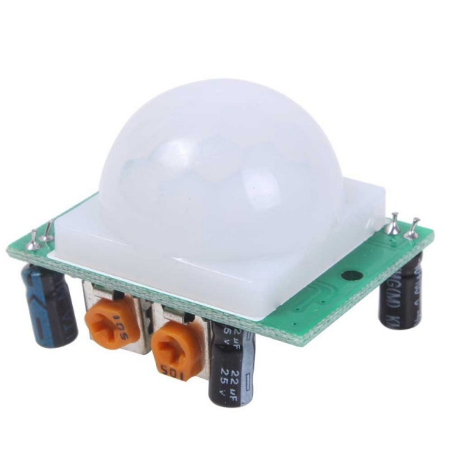

Fig 4- PIR Motion Detector Sensor Module (HC-SR501)

Specifications:

* Working Voltage Range: DC 4.5V- 20V
* Current Drain: <60uA
* Detection Range: <140°
* Voltage Output: High/Low level Signal: 3.3V TTL output
* Detection Distance: 3 to 7m (can be adjusted)
* Delay Time: 5 to 200s (Can be Adjusted, Default 5s +/- 3%)
* Blockade time: 2.5s (Default)
* Work temperature: -20-+80°C
* Dimension: 3.2cm x 2.4cm x 1.8cm (Approx)
* Sensitive Setting: Turn to Right, Distance Increases (About 7M); Turn to Left, Distance Reduce (About 3M)
* Time Setting: Turn to Right, Time Increases (About 200S); Turn to Left, Time Reduce (About 5S).

# Flat Vibration Motor Module (1034):

The Flat Vibration Motor Module (1034) is a compact and versatile device designed to provide vibration feedback in various electronic applications. Its slim and flat profile makes it easy to integrate into different devices such as smartphones, wearables, game controllers, and more.

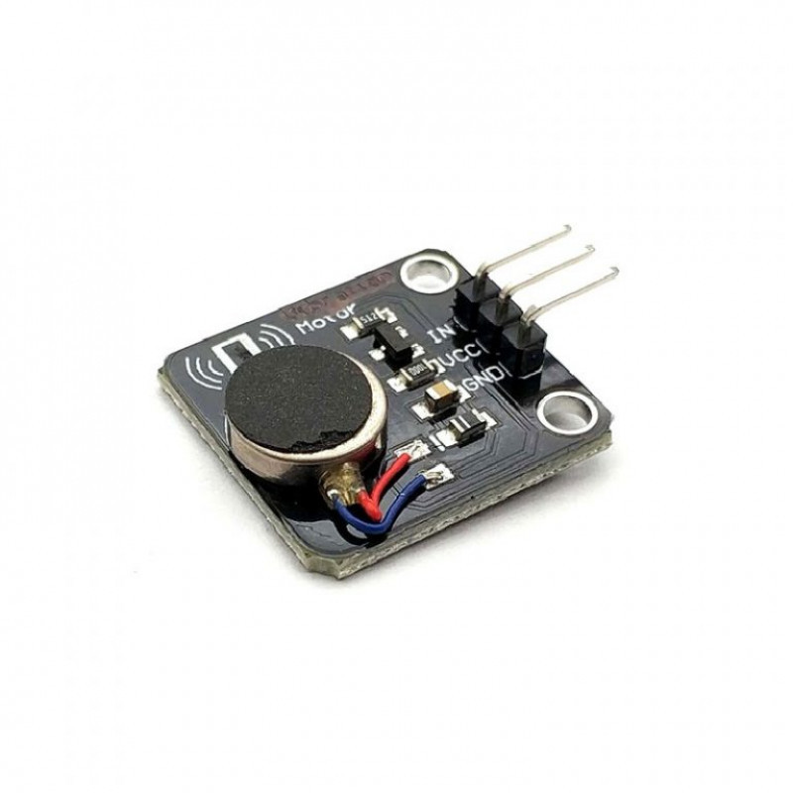

Fig 5- Flat Vibration Motor Module (1034)

Specifications**:**

* Operating Voltage: 3 to 5.3 VDC
* Motor Diameter: 10 mm
* Rated Speed: 9000 RPM
* Rated Voltage: 5 VDC
* Rated Current: up to 60 mA
* Starting Current: up to 90 mA
* Starting Voltage: 3.7 VDC
* Insulation Resistance: 10 M
* Dimensions: 23.5 × 21 × 8 mm
* Weight: 3 gm

# 5] Active Buzzer Module:

Active buzzers are the simplest to use. They are typically available in voltages from 1.5V to 24V. All you need to do is apply a DC voltage to the pins and it will make a sound. Active buzzers have polarity. The polarity is the same as an LED and a capacitor – the longer pin goes to positive. One downside of active buzzers is that the frequency of the sound is fixed and cannot be adjusted.

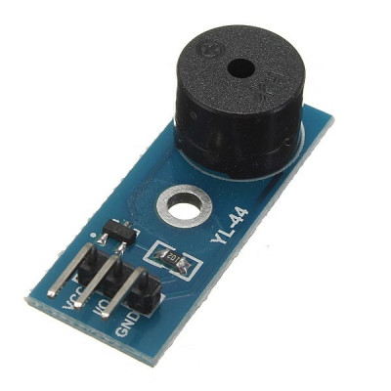

Fig 6- Active Buzzer Module

Specifications**:**

* Operating Voltage: 5V DC
* Sound Output: Typically, around 85-95 decibels (dB)
* Frequency Range: Approximately 2 kHz to 5 kHz
* Operating Current: Specified in milliamperes (mA)
* Operating Temperature Range: Varies depending on the specific model, but typically -20°C to +60°C
* Dimensions: 34.28 × 13.29 × 11.5 mm

# 6] 9V Battery

#### The 9V battery is an extremely common battery that was first used in transistor radios. It features a rectangular prism shape that utilizes a pair of snap connectors which are located at the top of the battery. This battery is very efficient and provides power for more time.

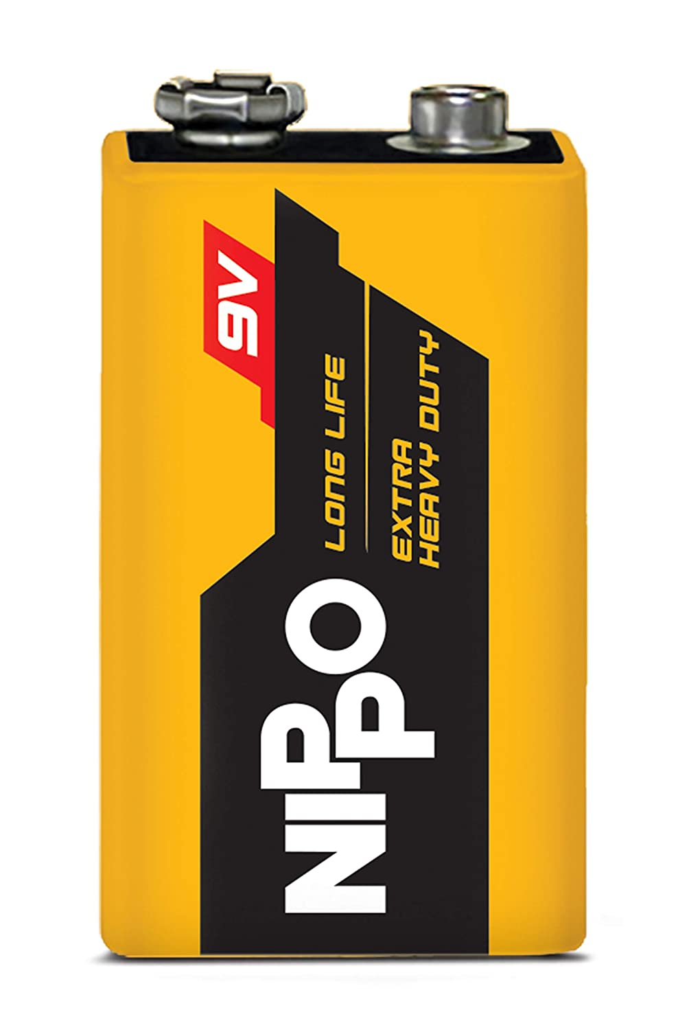

Fig 7- Battery(9V)

Specifications**:**

* Battery Type: Alkaline or Zinc Carbon
* Nominal Voltage: 9V DC
* Capacity: Varies depending on the specific model (e.g., 400mAh, 550mAh, etc.)
* Chemistry: Alkaline or Zinc Carbon
* Operating Temperature Range: Varies depending on the specific model, but typically -20°C to +60°C

# 7] Battery snap(9V) with DC jack:

# A 9v Battery Snap Connector with DC Jack with Battery Connector Cap is an adapter which transfers the 9 volts from a battery to a DC power plug- which then can be plugged in and power a DC power barrel jack with 9 volts. The 9V Battery Snap Connector with Power Plug provides the ability to conveniently use a 9V battery to power many common boards and modules such as the popular Arduino and compatible microcontrollers.

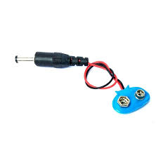

Fig 8- Battery snap(9V) with DC jack

# 8] SPDT slide switch:

A Single Pole Dual Throw (SPDT) slide switch is a switch that only has a single input and can connect to two outputs. This means it only has one input terminal and two output terminals.

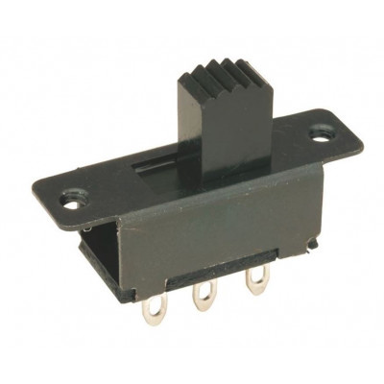

Fig 9- SPDT slide switch

# 9] Male to Female jumper wires:

Male ends have a pin protruding and can plug into things, while female ends do not and are used to plug things into.

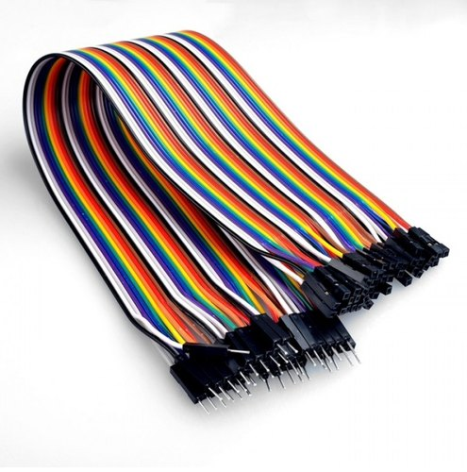

Fig 10- Male to Female jumper wires

# CHAPTER 8

**ARCHITECTURE OF PROJECT**

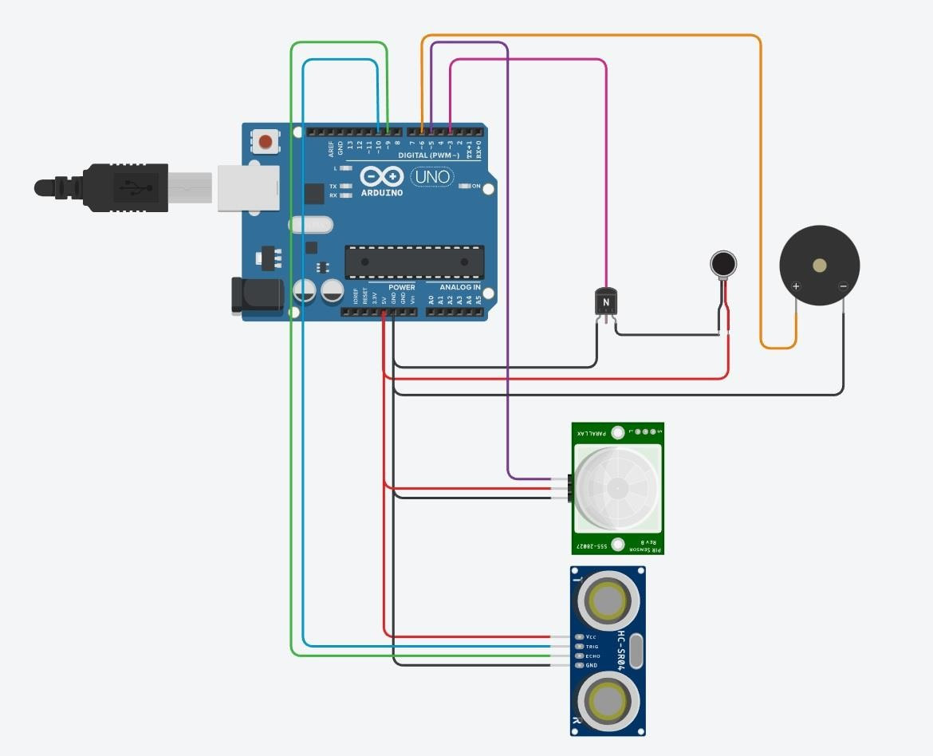

Fig 11- Simulation of Project

Simulation link- <https://www.tinkercad.com/things/7qhMgRsY0k2%20>

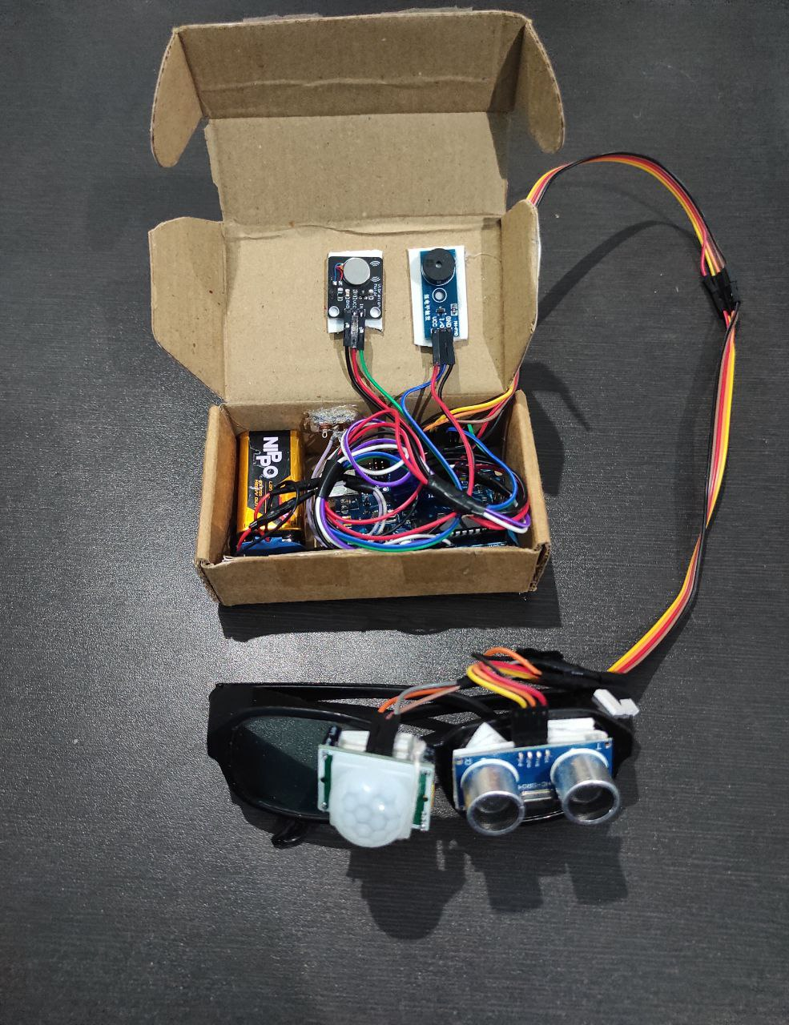

Fig 12- Prototype (model)

# CHAPTER 9 WORKING

Start

Measure Distance

Check state of PIR sensor

Is distance <=100

True False

Is pirState==HIGH

True False

Start flat vibration motor only

Start flat vibration motor and buzzer

Stop

Fig 13- Flowchart

1. Ultrasonic glasses for the blind are a wearable device designed to help people who are visually impaired or blind navigate their surroundings using ultrasonic sensor, PIR sensor as input devices and a haptic vibration motor, buzzer as the output device.
2. The glasses work by emitting high-frequency sound waves from ultrasonic sensors, which bounce off objects in the environment and return to the sensors, also PIR sensor detect heat radiation radiated by the obstacle.
3. The time taken for the sound waves to return to the sensors is used to determine the distance of the objects from the wearer, also radiations is detected or not.
4. This information is then transmitted to a control unit i.e., Arduino Uno, which is usually located in a box which is placed in pocket of wearer. The control unit processes the data and sends signals to a haptic vibration motor as well as buzzer located in the same box.
5. The buzzer generates sound & haptic vibration motor generates vibrations that correspond to the distance and location of objects in the wearer's environment.
6. For example, if an object is very close to the wearer, the motor may generate a rapid vibration, while a slower vibration may indicate an object that is further away. Also if obstacle is living thing, then buzzer generates sound. By feeling these vibrations and sound, the wearer can gain a better understanding of their surroundings and avoid obstacles. Overall, Ultrasonic glasses for the blind provide a valuable tool for people with visual impairments to navigate their surroundings and improve their independence and quality of life.

# CHAPTER 10 ARDUINO Code

int pirPin = 5; // PIR sensor pin

int buzzerPin = 6; // Buzzer pin

int pirState = LOW; // PIR sensor state

int buzzerState = LOW; // Buzzer state

bool flag=false;

const int trigPin = 10;

const int echoPin = 9;

long duration;

float distance;

//long temp;

int del;

void setup() {

pinMode(LED_BUILTIN, OUTPUT);

pinMode(pirPin, INPUT); // Set PIR sensor pin as input

pinMode(buzzerPin, OUTPUT); // Set buzzer pin as output

pinMode(3,OUTPUT);

pinMode(trigPin, OUTPUT);

pinMode(echoPin, INPUT);

}

void loop() {

// Write a pulse to the HC-SR04 Trigger Pin

digitalWrite(trigPin, LOW);

delayMicroseconds(2);

digitalWrite(trigPin, HIGH);

delayMicroseconds(10);

digitalWrite(trigPin, LOW);

// Measure the response from the HC-SR04 Echo Pin

duration = pulseIn(echoPin, HIGH);

// Determine distance from duration

// Use 343 metres per second as speed of sound

distance= duration*0.03433/2;

if(distance>=2 && distance<25){

analogWrite(3, 168); // analogWrite(pin,value)

del=100;

delay(del);

fun();

}

else if(distance>=25 && distance<50){

analogWrite(3, 168); // analogWrite(pin,value)

del=200;

delay(del);

fun();

}

else if(distance>=50 && distance<75){

analogWrite(3, 168); // analogWrite(pin,value)

del=300;

delay(del);

fun();

}

else if(distance>=75 && distance<=100){

analogWrite(3, 168); // analogWrite(pin,value)

del=400;

delay(del);

fun();

}

else{

analogWrite(3, 0); // analogWrite(pin,value)

del=500;

delay(del);

fun();

}

analogWrite(3, 0); // analogWrite(pin,value)

delay(del);

}

void fun(){

if(digitalRead(pirPin)==HIGH && flag==false){

flag=true;

digitalWrite(LED_BUILTIN, HIGH);// If motion is detected

analogWrite(buzzerPin, 10);

delay(200);

digitalWrite(LED_BUILTIN, LOW);

analogWrite(buzzerPin, 255);

}

else{

flag=false;

}

}

# Chapter 11

**ADVANTAGES:-**

1. It has sensing capability to sense all the material types.
2. This sensor is not affected due to atmospheric dust, rain, snow etc.
3. The PIR sensor can detect whether obstacle is living thing or not.
4. Ultrasonic sensor has higher sensing distance (in centimeters and inches) compare to inductive/capacitive proximity sensor types.
5. It provides haptic(vibration) feedback as well as sound from buzzer.

**LIMITATIONS:-**

1. Ultrasonic sensor is very sensitive to variation in the temperature.
2. The PIR sensor can be rarely triggered by sources of infrared radiation other than human or animal motion, such as changes in temperature, sunlight

# APPLICATIONS :-

1. As a navigation guide for the blind or people with impaired vision
2. Obstacle Detection
3. Classify obstacle as living or non-living

.

# CHAPTER 12 CONCLUSION

Ultrasonic glasses for the blind are a promising technology that can significantly improve the daily lives of visually impaired individuals. These glasses use ultrasonic waves to detect obstacles and provide haptic feedback to the wearer, as well as use Infrared Radiation to state whether obstacle is living thing or not and provide sound to the wearer allowing them to navigate their surroundings with greater ease and independence. The technology is still in the early stages of development, and there are some limitations to consider, such as limited detection range and accuracy.

However, with further research and advancements in technology, Ultrasonic glasses have the potential to become an essential tool for the blind and visually impaired community. They offer a new level of freedom and independence that was previously unavailable, and it is exciting to think about the possibilities that these glasses may bring in the future. We can add camera and Artificial Intelligence to the glasses to recognize obstacle & also can provide GPS navigation and voice calling.

# CHAPTER 13 REFERENCES

1. “Automated Walk-in Assistant for the Blinds” by Muhammad Sheikh Sadi, Saifuddin Mahmud, Md. Mostafa Kamal, Abu Ibne Bayazid. Published in 2014 in the IEEE International Conference on Electrical Engineering and Information & Communication Technology
2. “A Wearable Walking Support System to provide safe direction for the Blind” by Kataoka Hiroto, Harashima Katsumi. Published in 2019 in the IEEE 34th International Technical Conference on Circuits/Systems, Computers and Communications (ITC-CSCC)
3. “Development of Glasses for Guiding Visually Impaired Using Ultrasonic Sensor and Microcontroller” by Wawan Setiawan, Rasim, and Jajang Kusnendar. Published in 2014 in the Journal of Multidisciplinary Engineering Science and Technology (JMEST)
4. “A Unique Smart Eye Glass for Visually Impaired People” by Md. Razu Miah, Md. Sanwar Hussain. Published in 2018 in the IEEE International Conference on Advancement in Electrical and Electronic Engineering (ICAEEE)
5. “Smart Guiding Glasses for Visually Impaired People in Indoor Environment” by Jinqiang Bai, Shiguo Lian, Zhaoxiang Liu, Kai Wang, Dijun Liu. Published in 2017 in the IEEE Transactions on Consumer Electronics
6. “Ultrasonic Glasses for the Blind: A Portable Aid for Obstacle Detection” by P. Mehta, A. Thakur, and A. Sharma. Published in 2017 in the IEEE Sensors Journal.
7. “Development of Ultrasonic Glasses for Blind People Using an ATmega328 Microcontroller” by M. Sahin, A. Erol, and H. Koyuncu. Published in 2019 in the journal of Intelligent & Robotic Systems.
8. “Ultrasonic Glasses for Visually Impaired: Human–Machine Interaction and Control System Design” by J. Geng, J. Fang, and J. Zhang. Published in 2021 in the IEEE Transactions on Instrumentation and Measurement.
9. “Ultrasonic Glasses for the Blind Using Raspberry Pi and Arduino” by M. Amor, A. Idoudi, and N. Bouden. Published in 2021 in the journal International Journal of Electrical and Computer Engineering (IJECE).
10. “Design and Implementation of Ultrasonic Glasses for the Blind Based on Wireless Sensor Network” by W. Zhang, C. Liao, and X. Huang. Published in 2021 in the IEEE International Conference on Artificial Intelligence and Computer Applications (ICAICA).